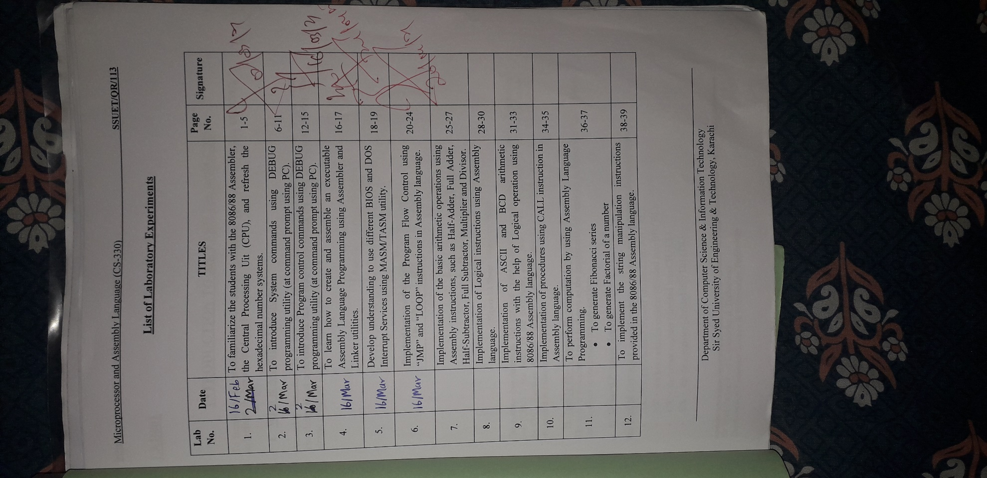Lab Index

NAME:- Junaid Jawed

ROLL-NUM:- 2019-CS-001

SECTION:- 5A

BATCH:- 2019

MICROPROCESSOR & ASSEMBLY LANGUAGE (CS-330) LABORATORY MANUAL

SUBMITTED TO:- Sir Faisal Yazdani

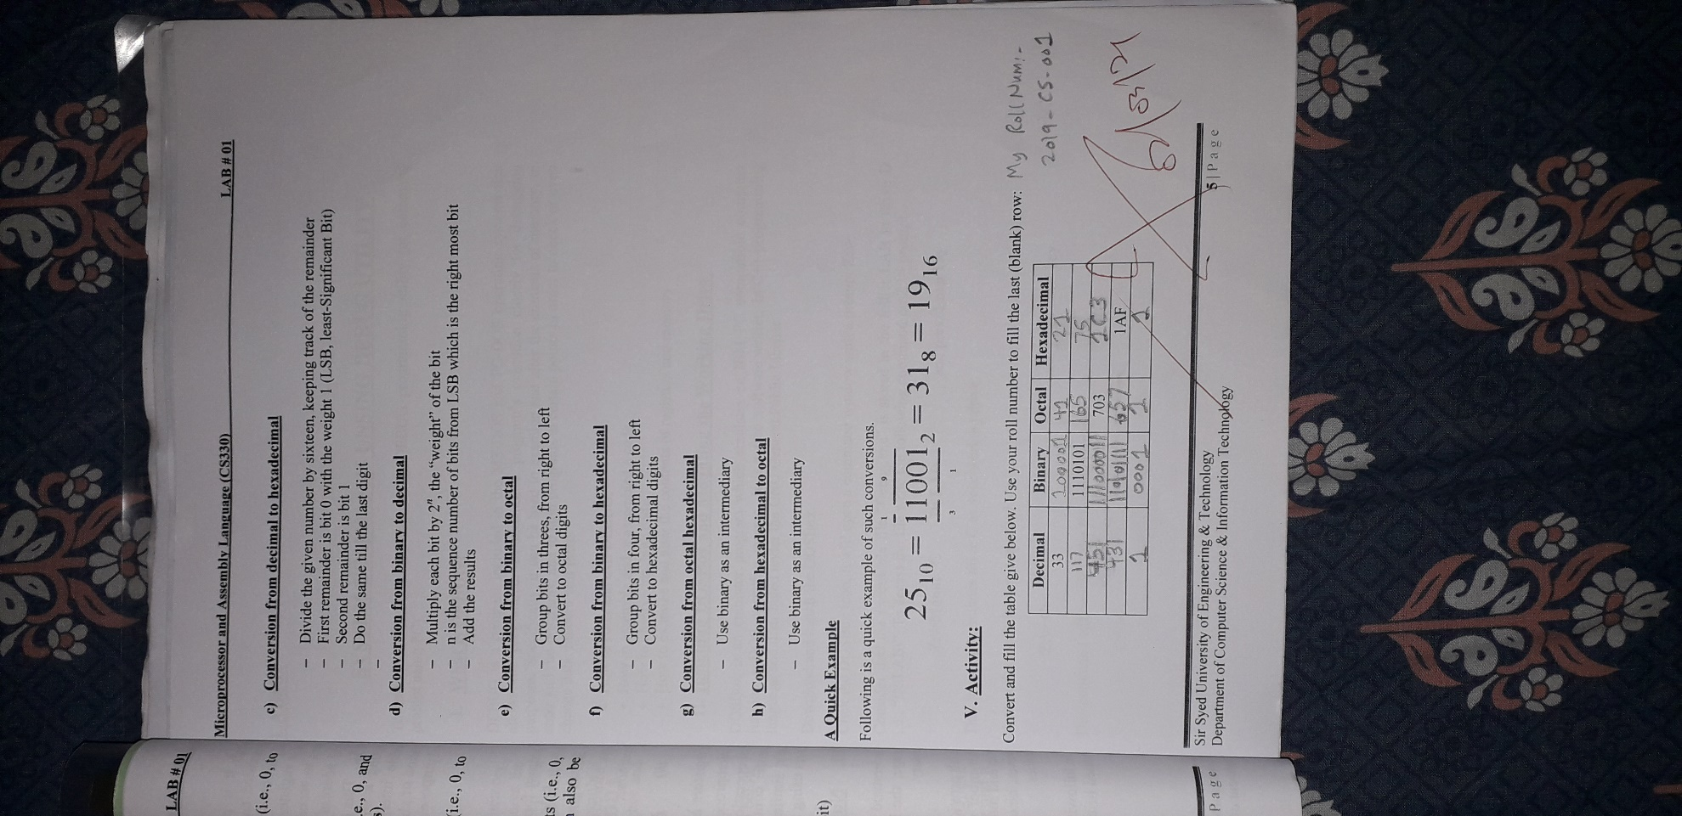Lab # 1

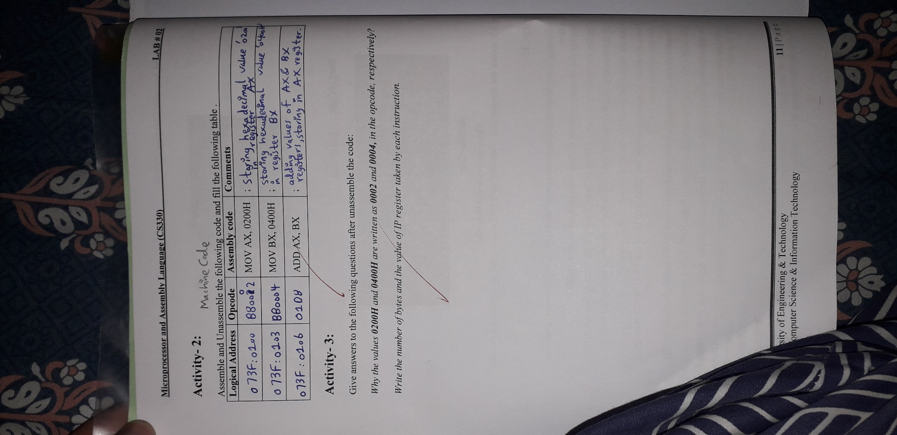Lab # 2

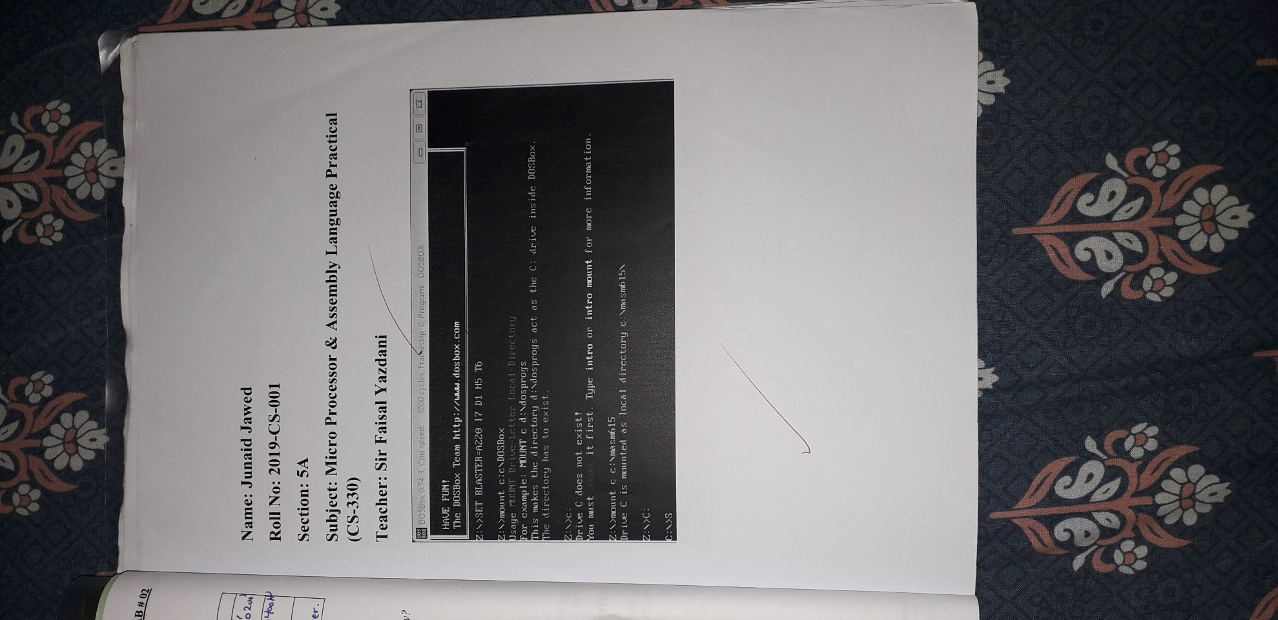

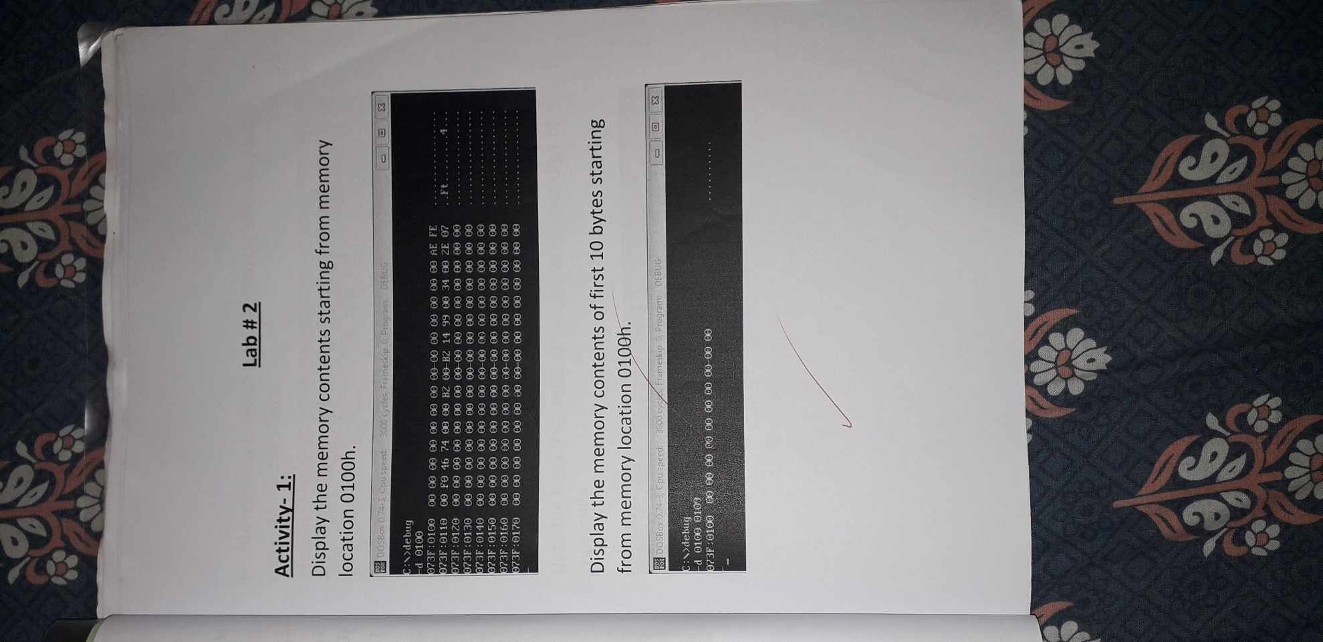

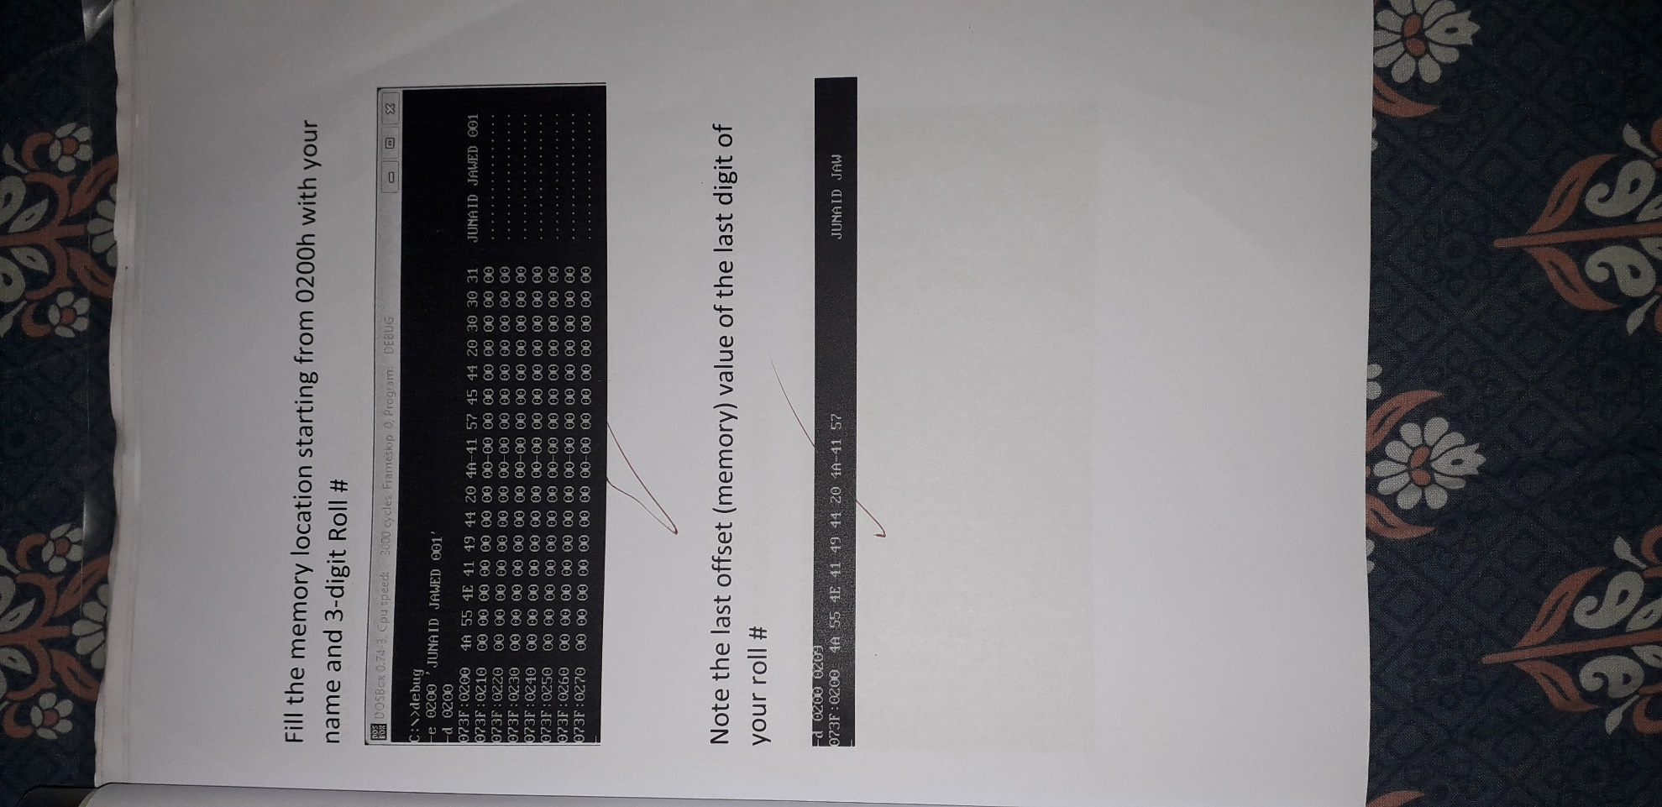

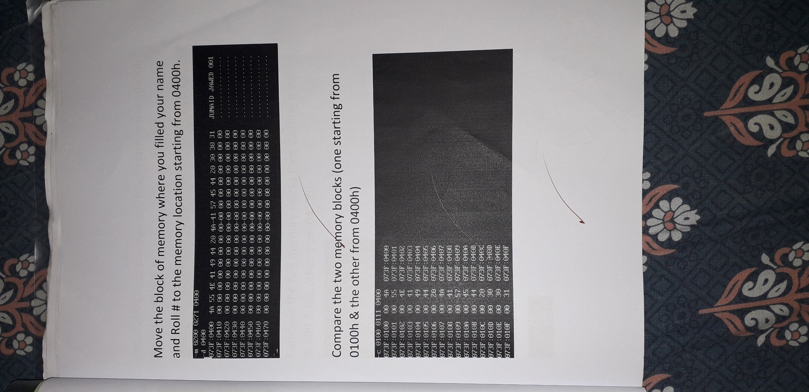

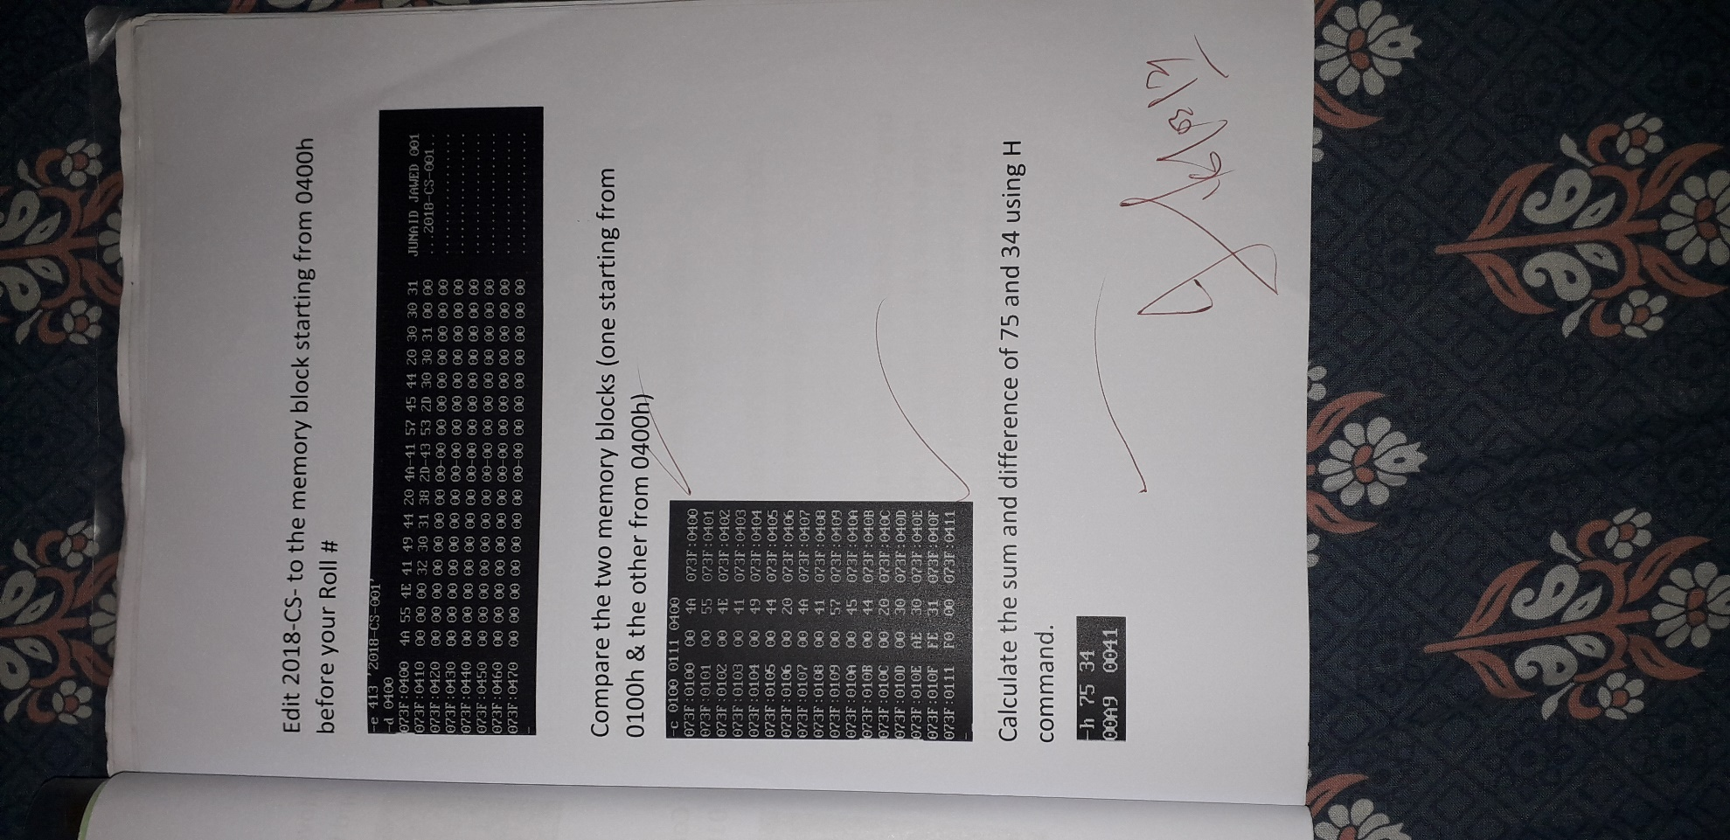

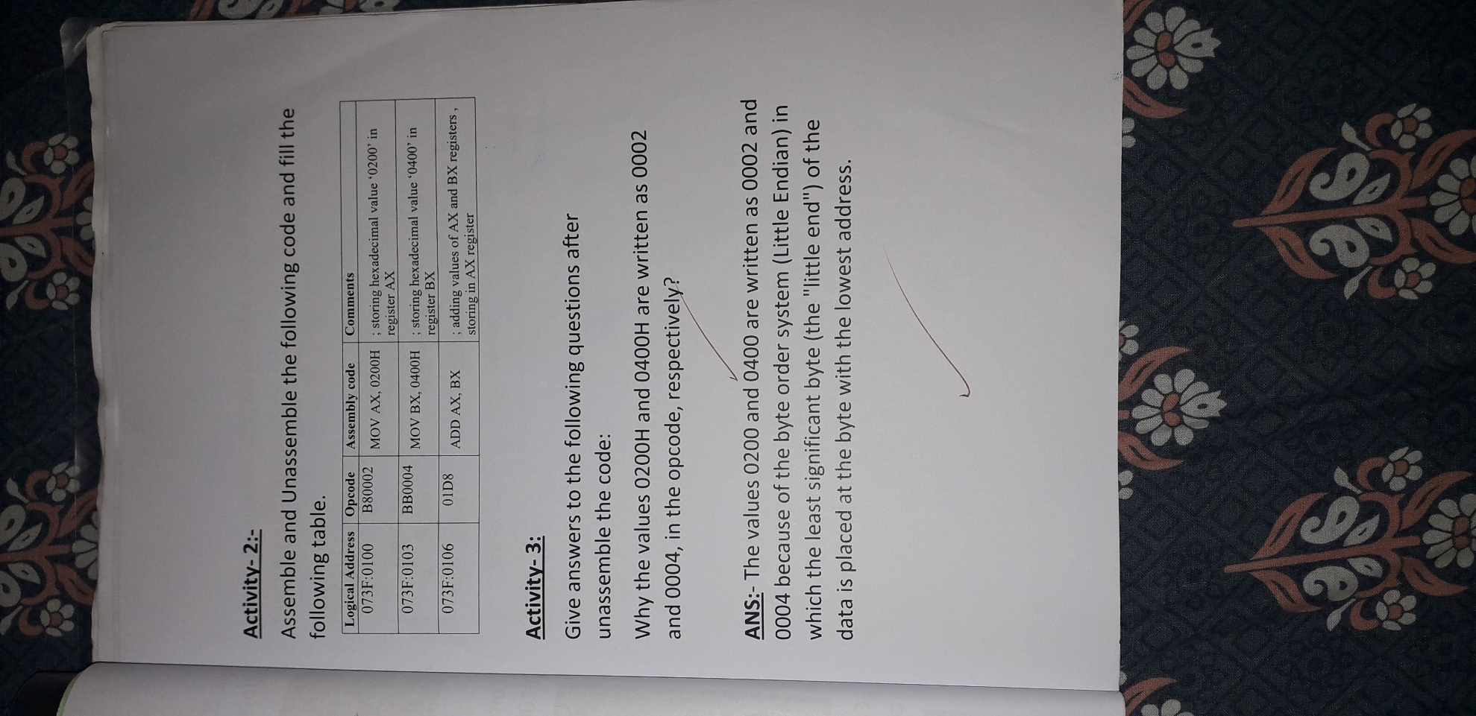

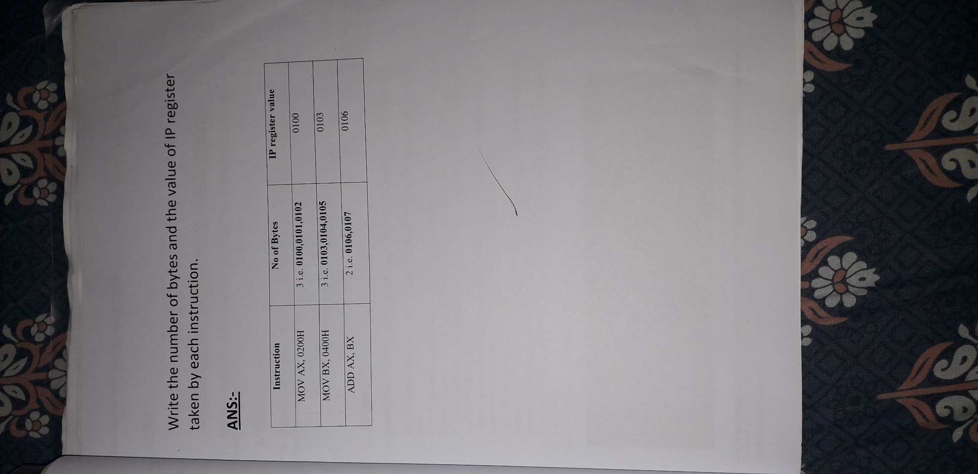

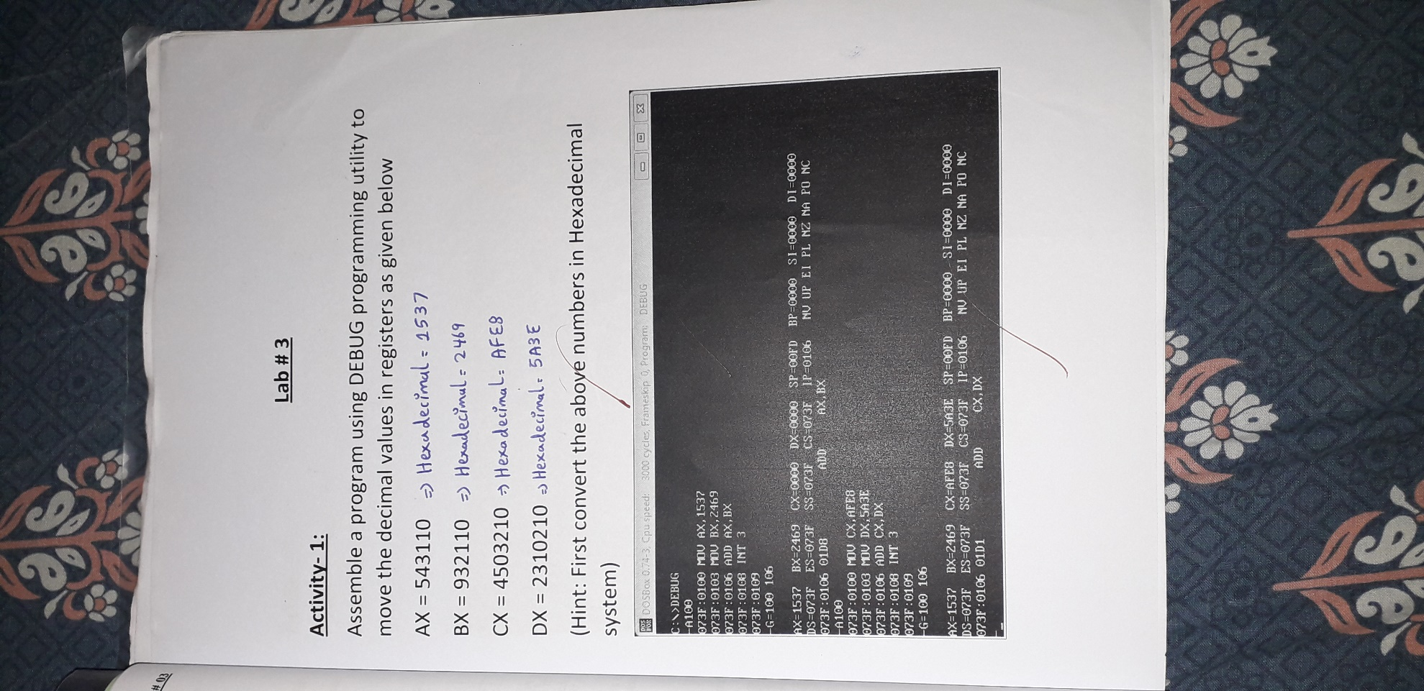Lab # 3

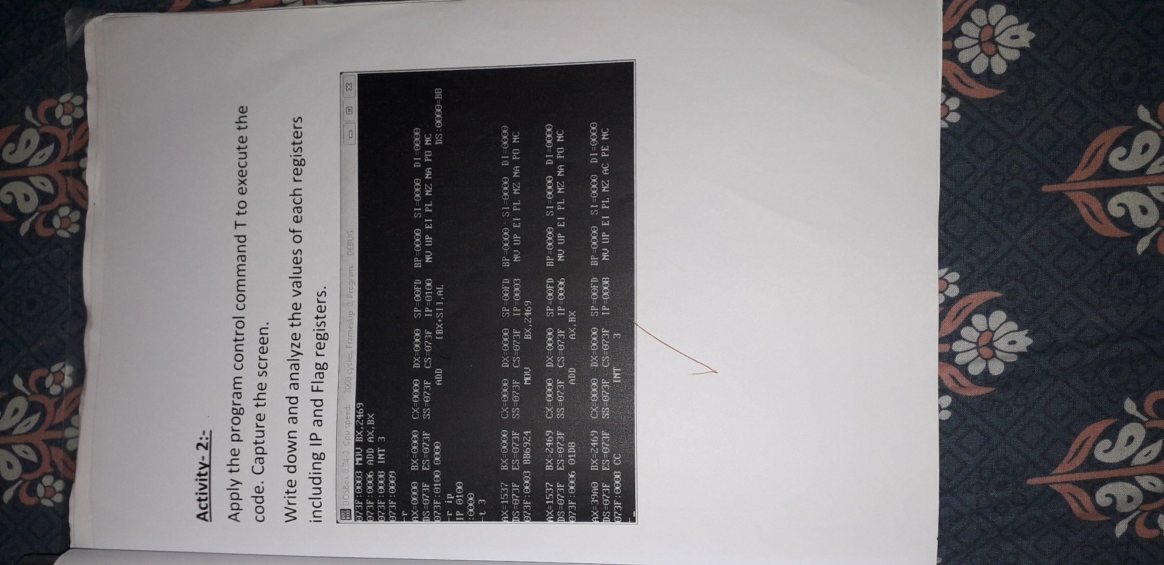

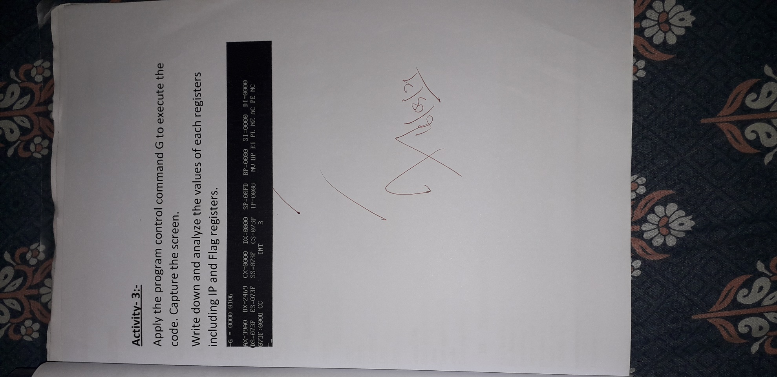

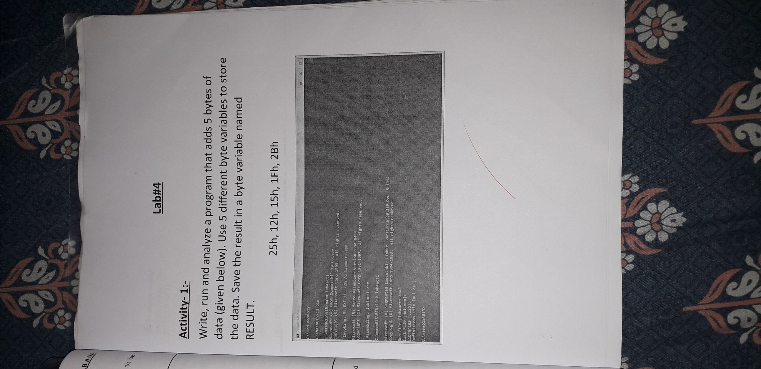Lab # 4

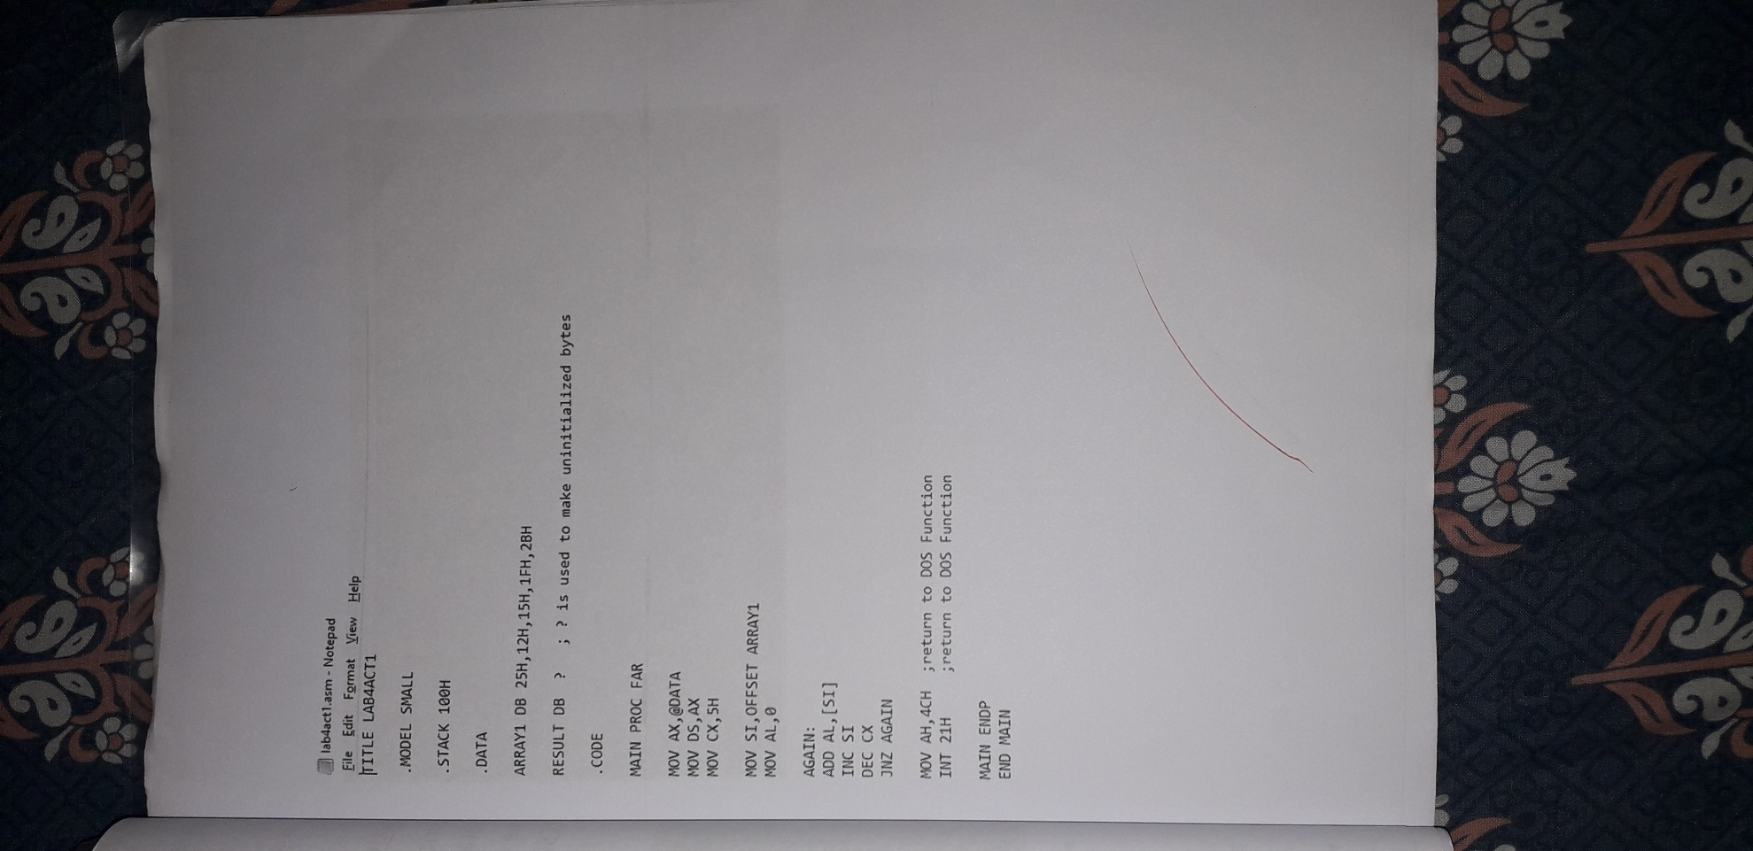

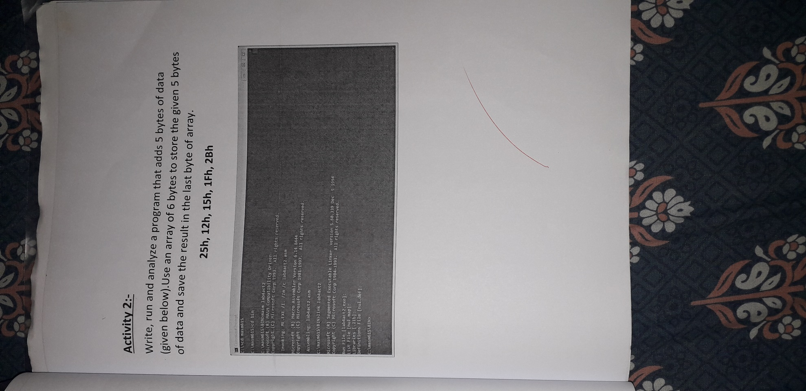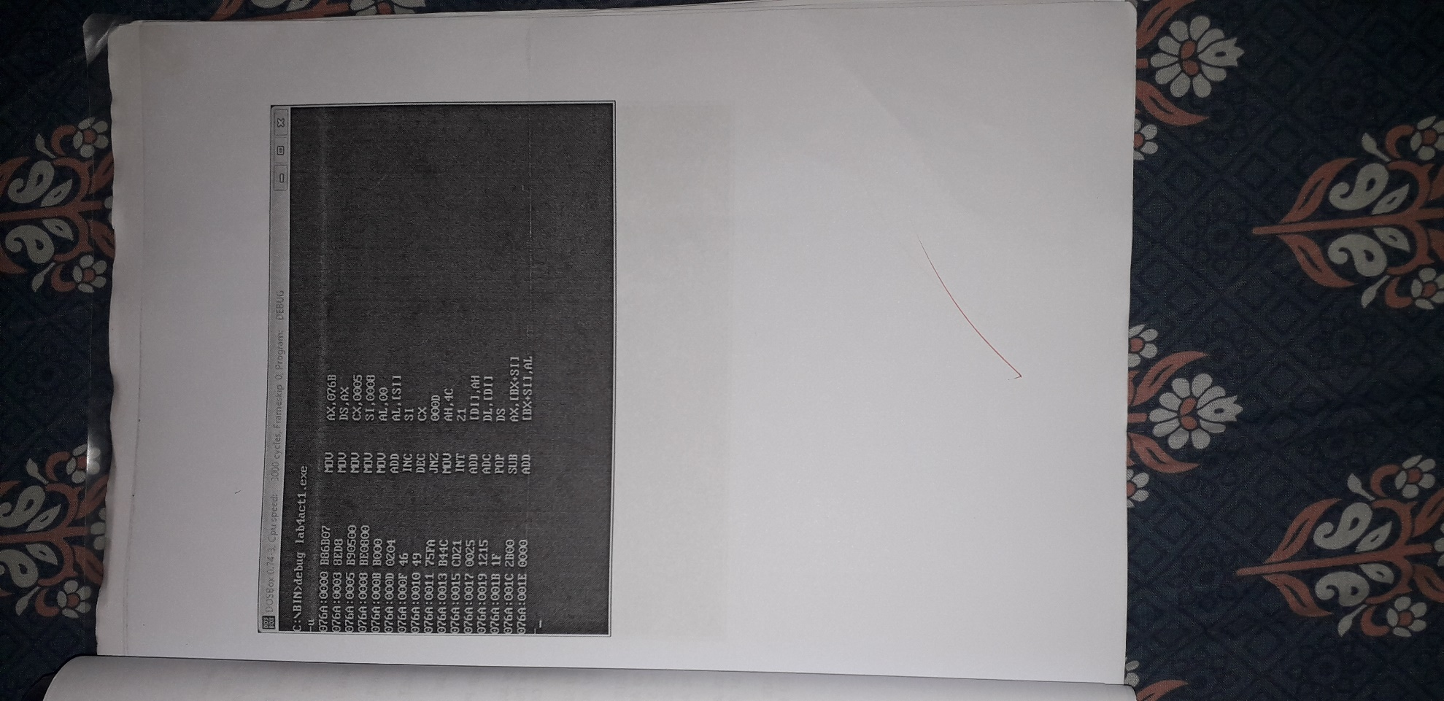



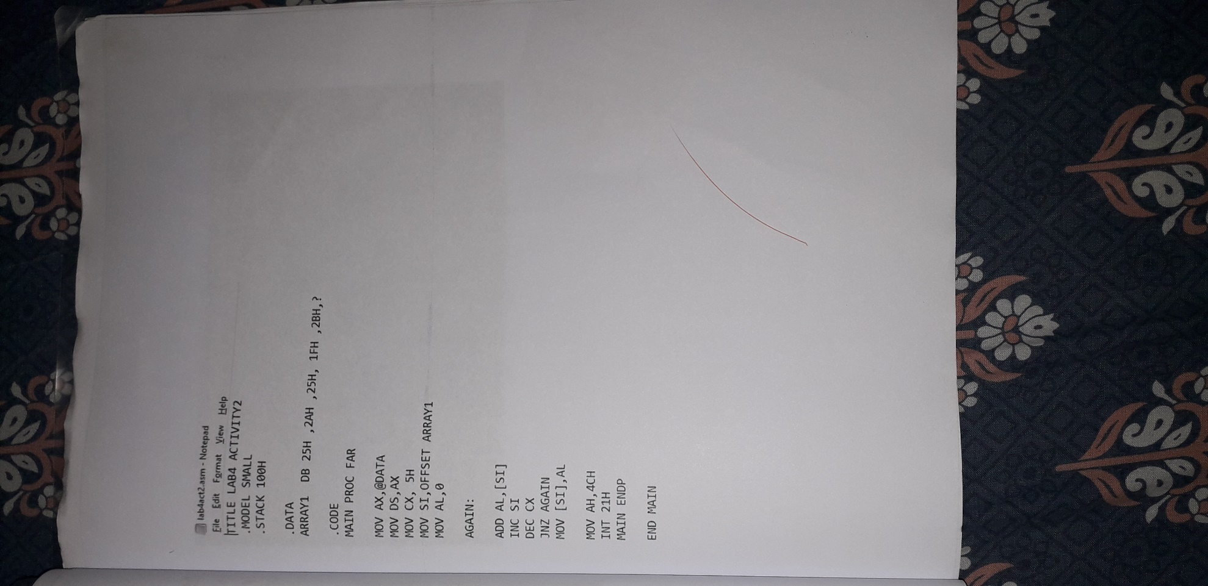

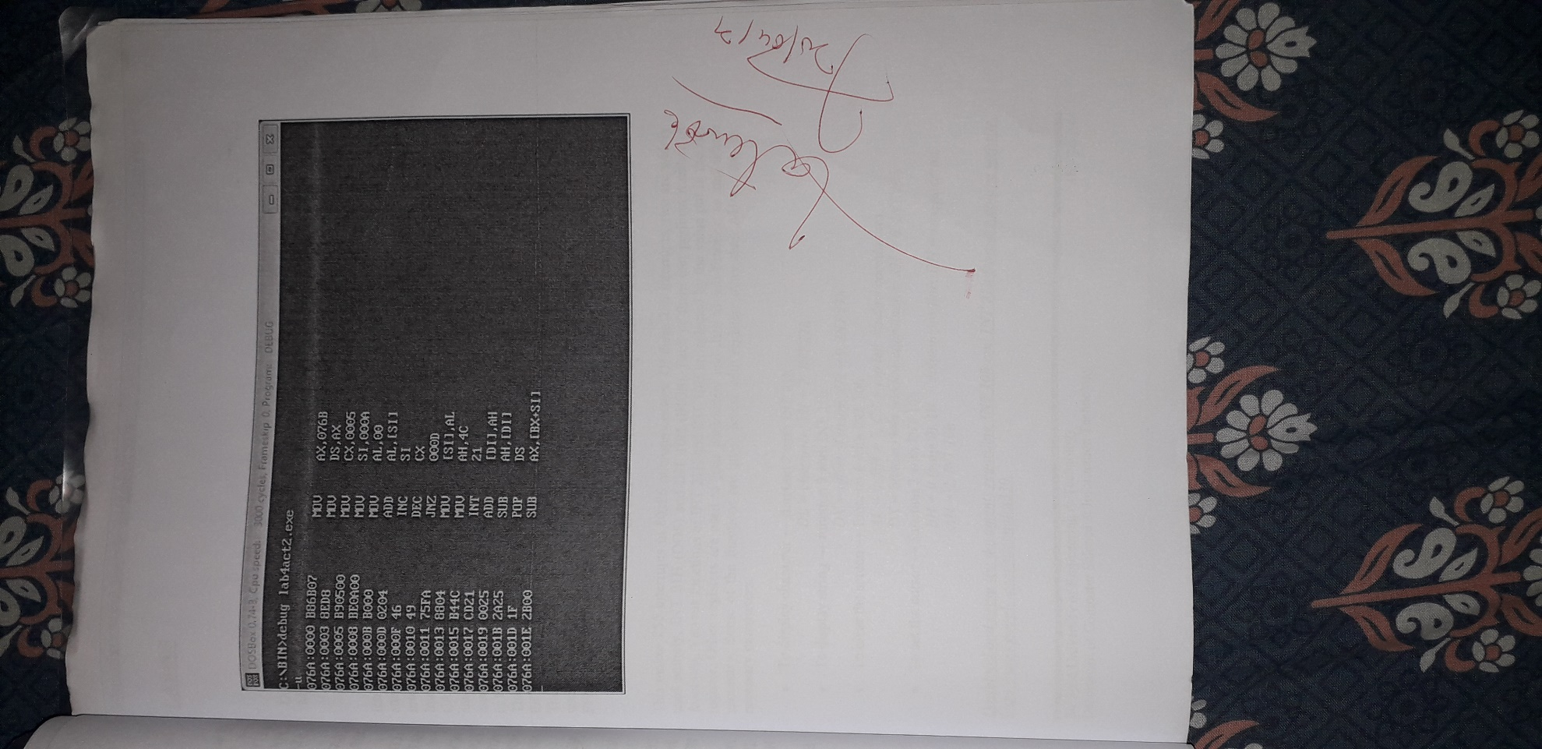

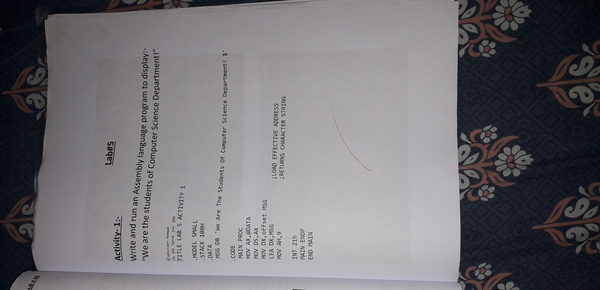Lab # 5

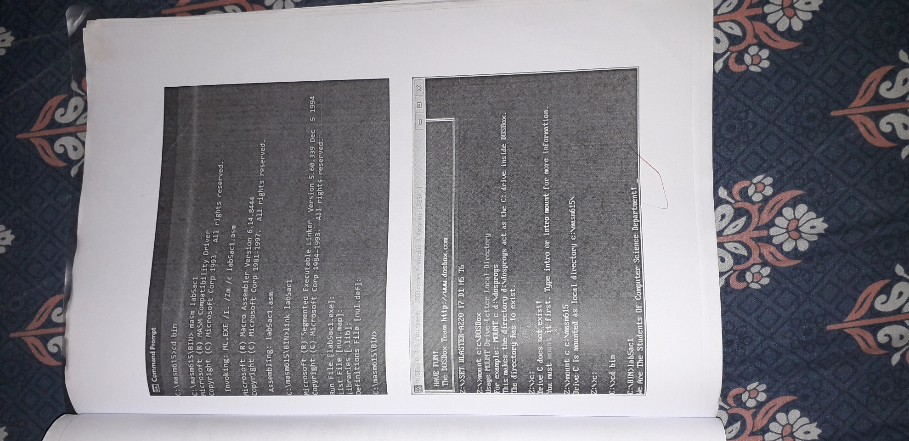

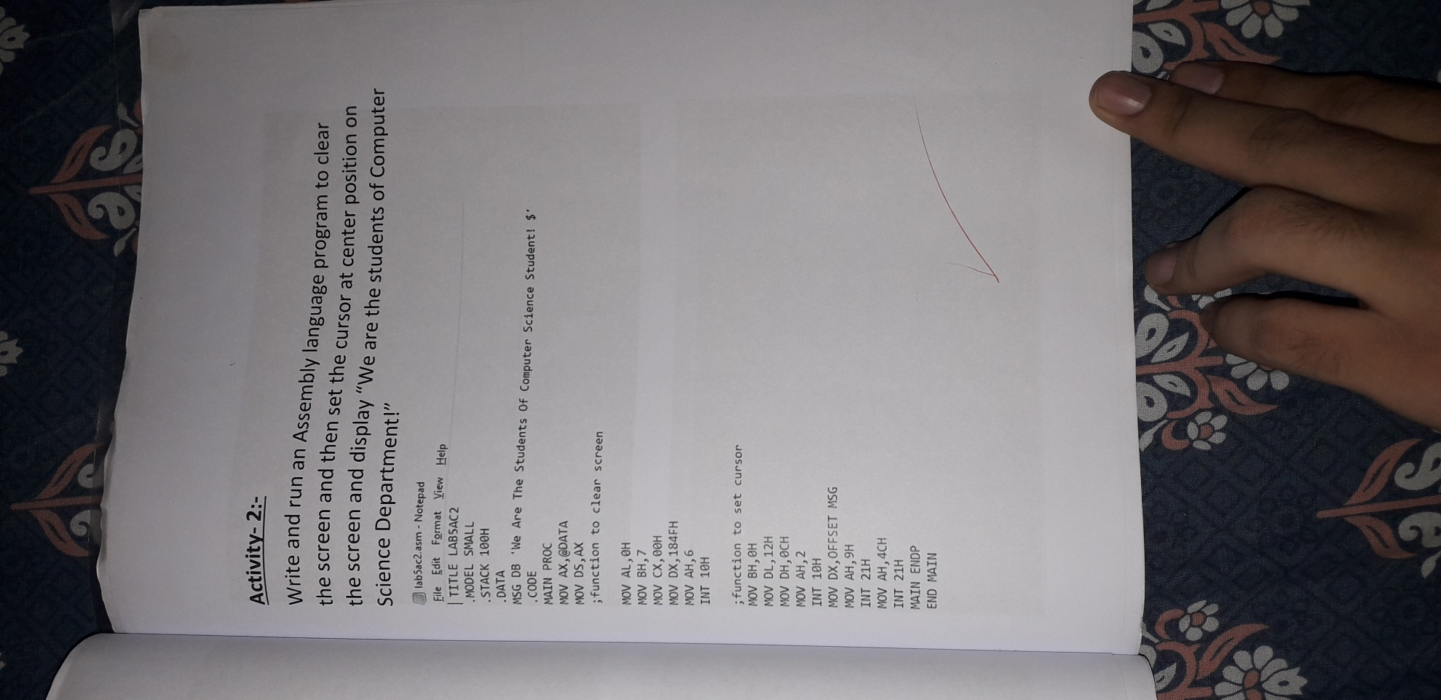

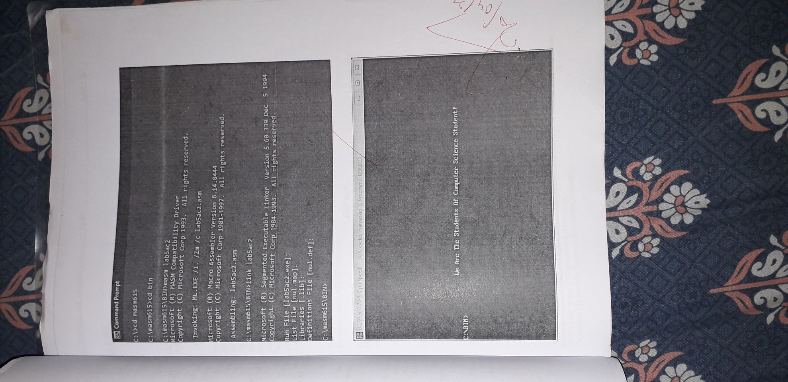

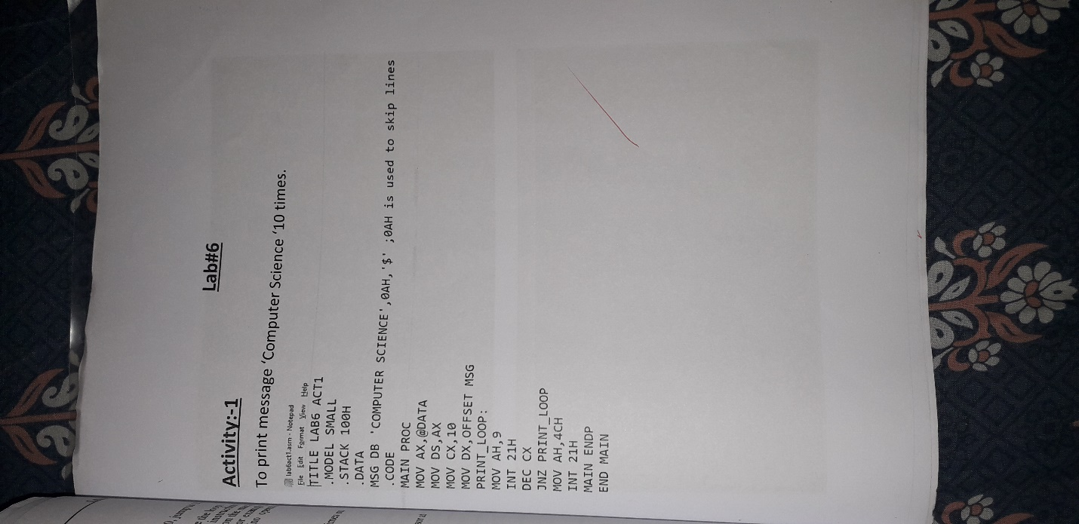Lab # 6

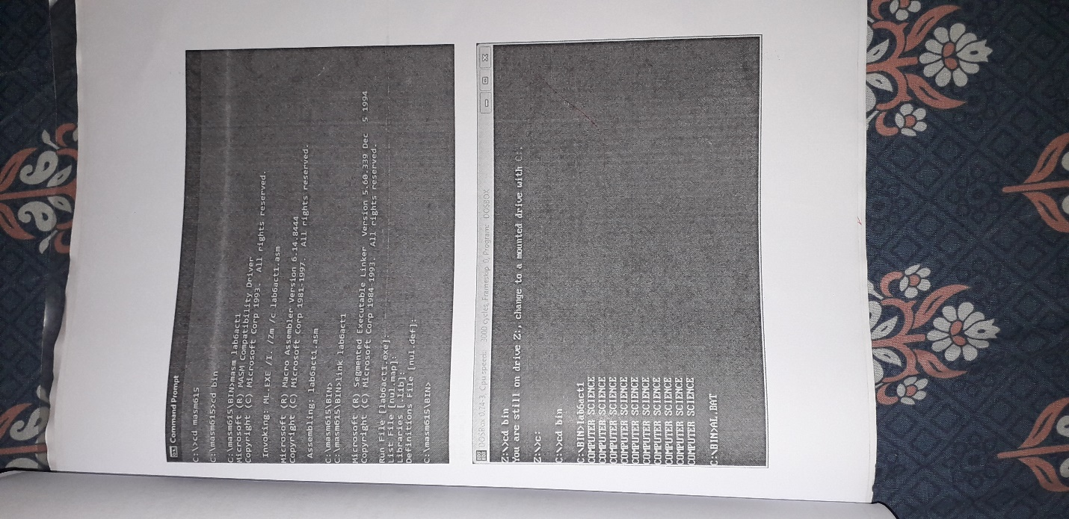

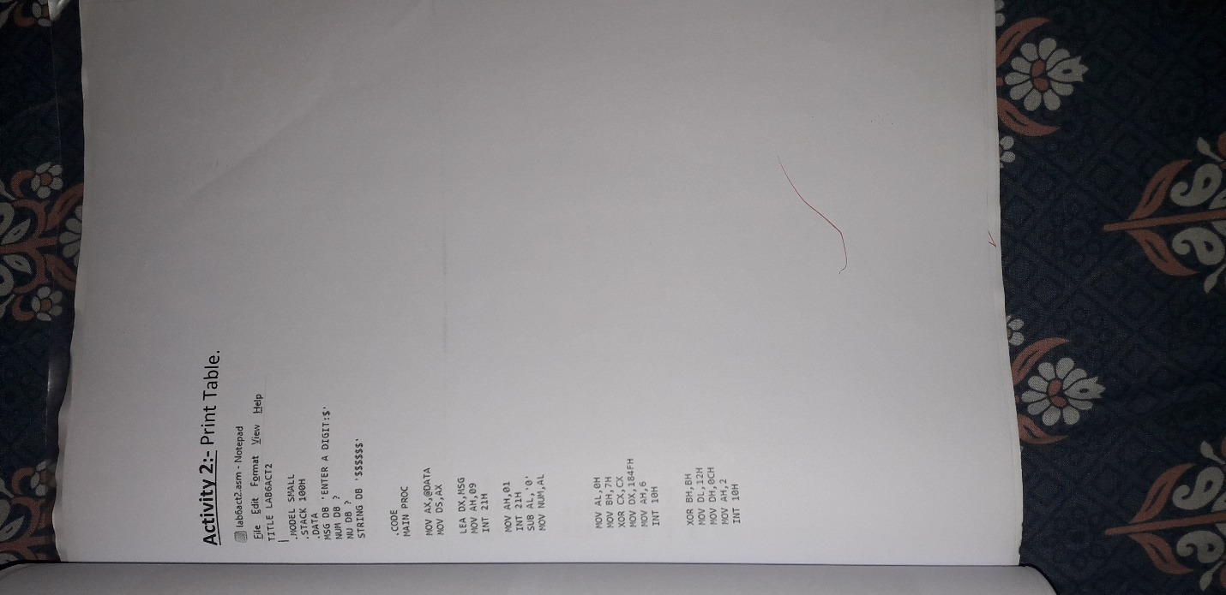

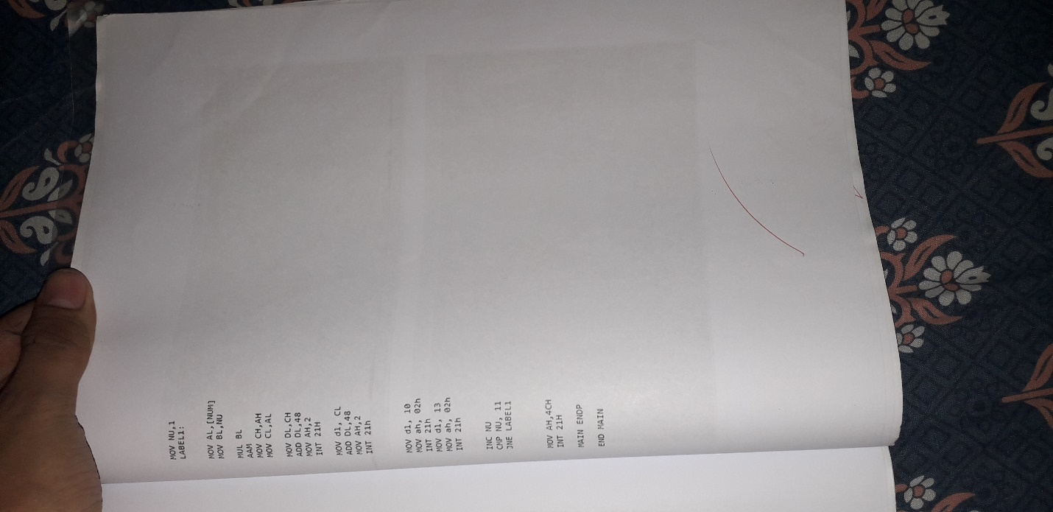

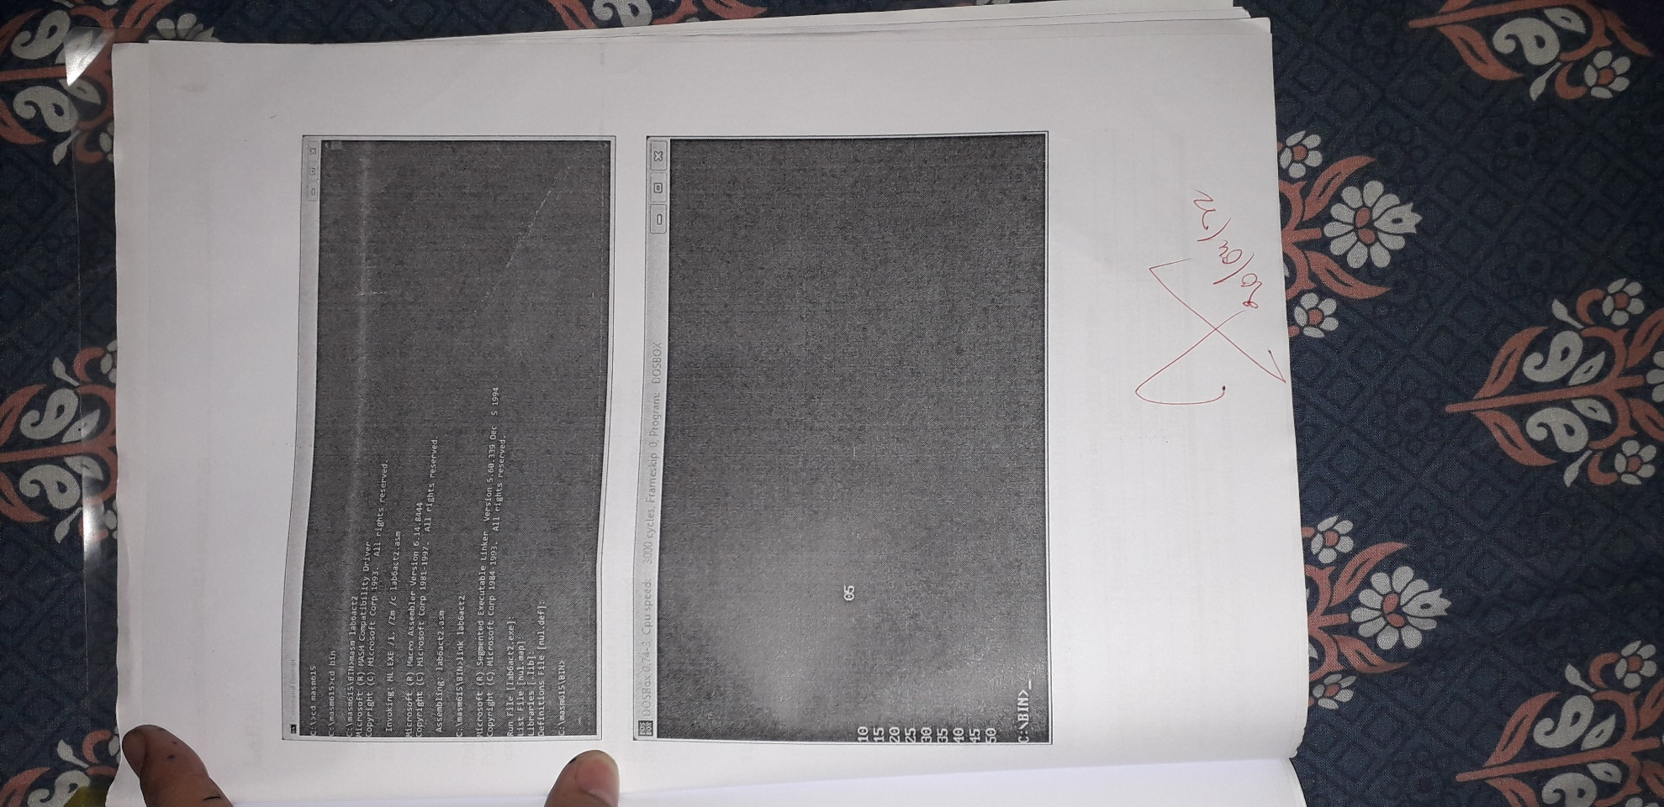

Lab # 7

Activity:- 1

Program to add two 32 bit numbers using ADC (add with carry) command.

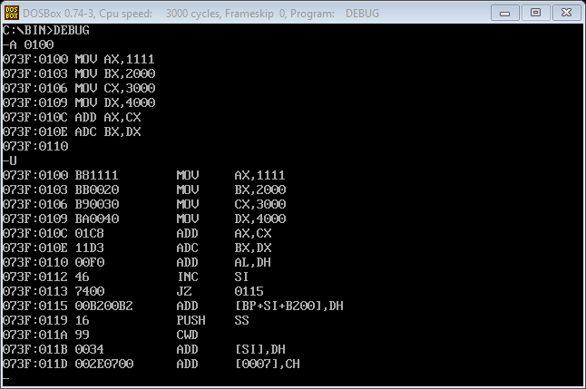MOV AX, 1111

MOV BX, 2000

MOV CX, 3000

MOV DX, 4000

ADD AX, CX

ADD BX, DX

Activity:- 2

Program to subtract two 32-bit numbers using SBB command.

MOV AX, 3000

MOV BX, 2000

MOV CX, 1000

MOV DX, 4000

SUB AX, DX

SUB BX, CX

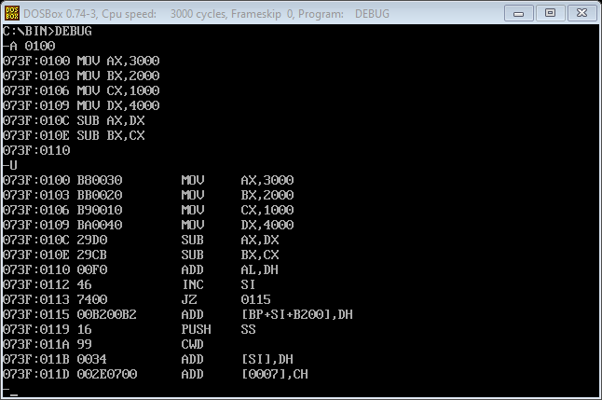

Activity:- 3

Program to multiply two numbers store in registers BL and CL, The result is stored in register DX.

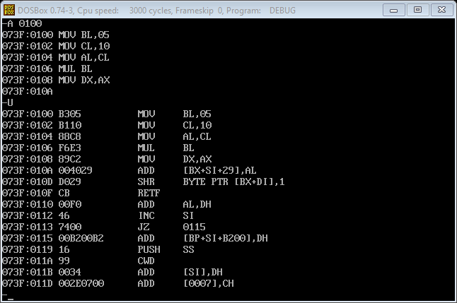MOV BL, 05

MOV CL, 10

MOV AL, CL

MUL BL

MOV DX, AX

Activity:- 4

Program to divide two numbers store in registers BL and CL.

MOV BL, 05

MOV CL, 10

MOV AH, 00

MOV AL, CL

DIV BL

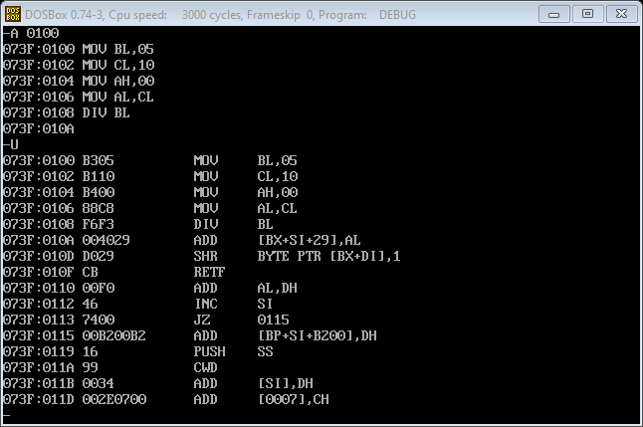

Lab # 8

Activity:-1

Assume that there is a class of five people with the following grades. Find the highest grade.

69h,87h,96h,45h,75h

Coding:-

TITLE LAB8ACT1

.MODEL SMALL

.STACK 100H

.DATA

GRADES DB 69H, 87H, 96H, 45H, 75H

HIGHEST DB ?

.CODE

MAIN PROC

MOV AX,@DATA

MOV DS,AX

MOV CX,4

MOV BX,OFFSET GRADES

MOV AL,[BX]

LOOP_BACK:

CMP AL,[BX+1]

JC SWAP

SWAP_BACK:

INC BX

LOOP LOOP_BACK

JMP TER

SWAP:

MOV AL,[BX+1]

JMP SWAP_BACK

TER:

MOV HIGHEST,AL

MOV AH,4CH

INT 21H

MAIN ENDP

END MAIN

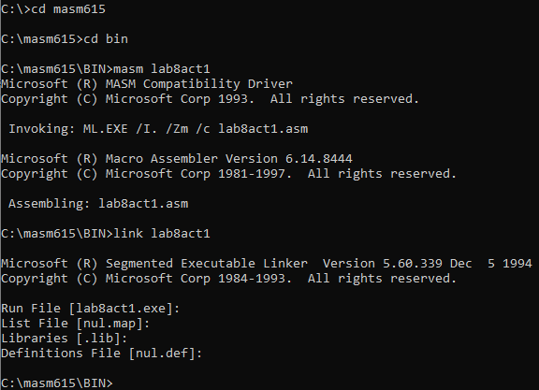

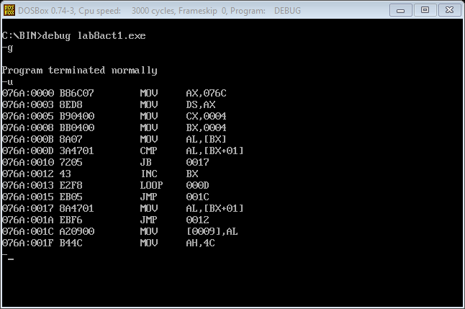

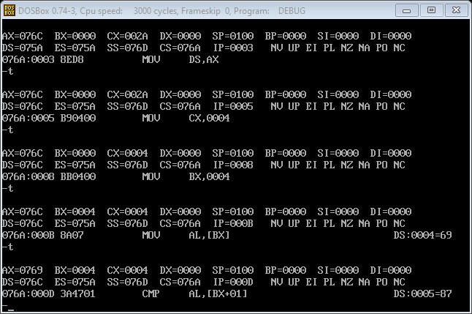

Activity:-2

Write a program to convert alphabets of your first name from lowercase to uppercase. The first name should be provided in the form of array.

For example, the first name is “shakir”. It should be defined as:-.data

first name db “shakir”

Coding:-

TITLE LAB8ACT2

.MODEL SMALL

.STACK 100H

.DATA

F_NAME DB 'junaid'

.CODE

MAIN PROC

MOV AX,@DATA

MOV DS,AX

MOV CX,6

MOV BX,OFFSET F_NAME

DISPLAY:

MOV DL,[BX]

SUB DL,32

INC BX

MOV AH,2

INT 21H

LOOP DISPLAY

MOV AH,4CH

INT 21H

MAIN ENDP

END MAIN

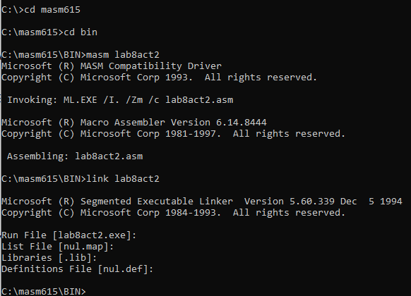

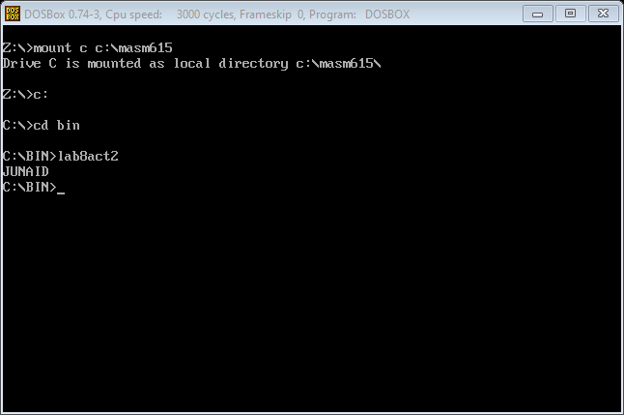

Activity:- 3

Write a program to find the number of ones in the number 76h.

Coding:-

Title Lab 8 activity 3

.Model Small

.Stack 100h

.Data

num db 76h

ones db 0

.Code

Main Proc

mov ax,@data

mov ds,ax

mov al,num

mov cx,7

mov bl,ones

SBACK:

ROR al,1

JC COUNT

LBACK:

LOOP SBACK

JMP TER

COUNT:

Inc BL

Jmp LBACK

TER:

mov ones,bl

mov ah,4ch

int 21h

Main endp

end Main

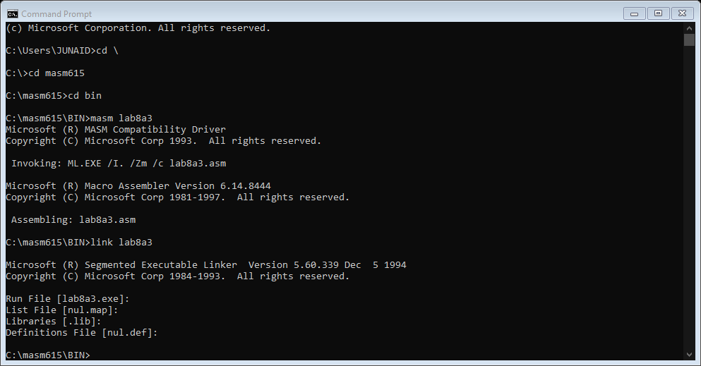

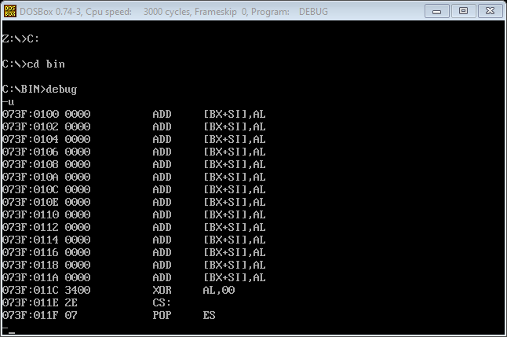

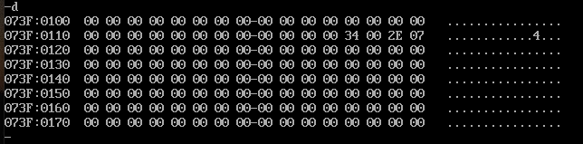

Lab # 9

Activity 1:-

Write a program to count no. 1s in a byte. Provide the count in BCD.

Coding:-

TITLE LAB9ACT1

.MODEL SMALL

.STACK 100H

.DATA

DB 64 DUP (?)

NUM DB 76H

ONES DB 00

.CODE

MAIN PROC

MOV AX,@DATA

MOV DS,AX

;COUNTING NO OF ONES

MOV AL,NUM

MOV CX,07

MOV BH,00

MOV BL,ONES

SBACK:

ROR AL,1

JC COUNT

LBACK:

LOOP SBACK

JMP TER

COUNT:

INC BL

JMP LBACK

TER:

;CONVERTING INTO UNPACKED BCD

MOV AL,BL

MOV DL,01

MUL DL

AAM

OR AX,3030H

MOV BX,AX

;PRINTING BCD VALUES

MOV AH,2

MOV DL,BH

INT 21H

MOV AH,2

MOV DL,BL

INT 21H

MOV AH,4CH

INT 21H

MAIN ENDP

END MAIN

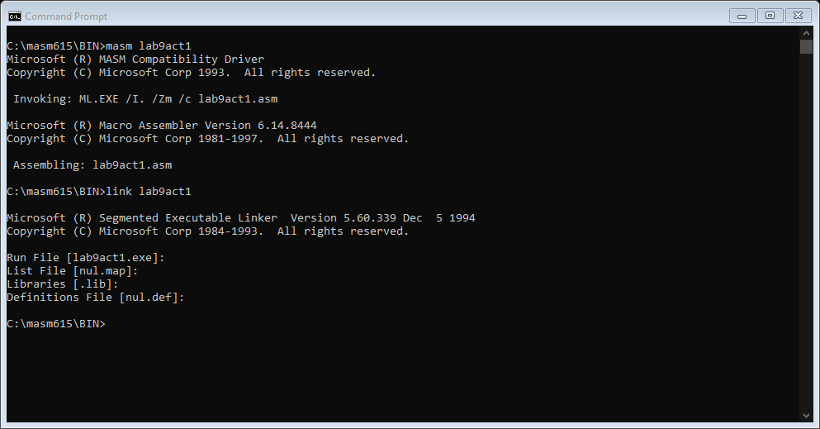

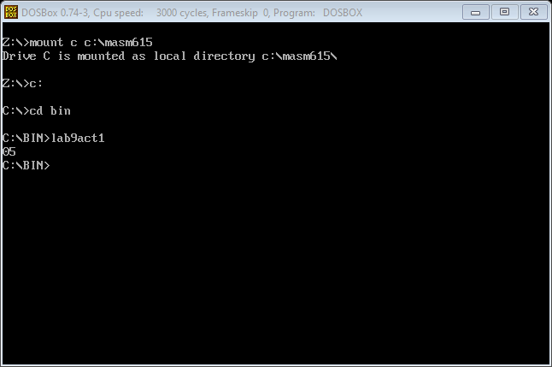

Activity 2:-

Write a program to count no. 1s in a word. Provide the count in BCD.

Coding:-

Title Lab 9 Activity 2

.Model Small

.Stack 100H

.Data

DB 64 DUP (?)

NUM DW 7676H

ONES DB 00

.Code

MAIN PROC

MOV AX,@Data

MOV DS,AX

;COUNTING NO OF ONES

MOV AX,NUM

MOV CX,16

MOV BH,00

MOV BL,ONES

SBACK:

ROR AX,1

JC COUNT

LBACK:

LOOP SBACK

JMP TER

COUNT:

INC BL

JMP LBACK

TER:

;CONVERTING UNPACKED BCD INTO ASCII

MOV AL,BL

MOV DL,01

MUL DL

AAM

OR AX,3030H

MOV BX,AX

;PRINTING ASCII VALUES

MOV AH,2

MOV DL,BH

INT 21H

MOV AH,2

MOV DL,BL

INT 21H

MOV AH,4CH

INT 21H

MAIN ENDP

END MAIN

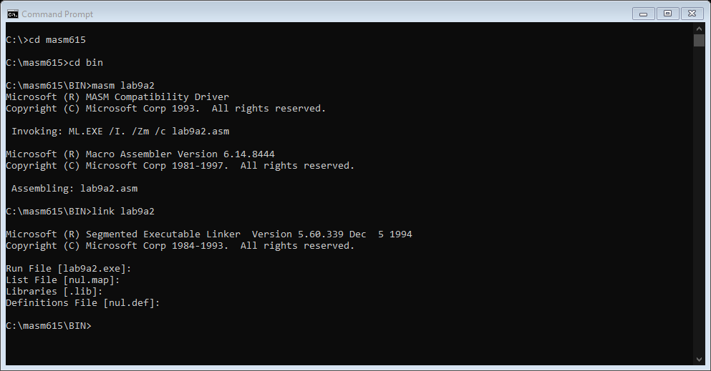

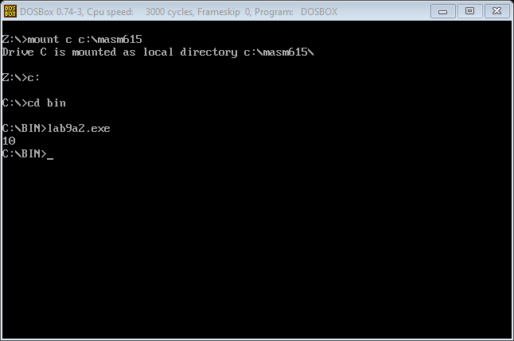

Activity 3:-

Take two 1-digit inputs (from 0-9) from user through a keyboard.Perform the following operations.The results for all the operations must be displayed on the screen.

(a)Addition:-

Coding:-

lab9Title LAB 9 Activity 3a

.Model Small

.Stack 100H

.Data

Msg DB 'Enter First Number = $'

Msg1 DB 0ah,0dh,'Enter Second Number = $'

Msg2 DB 0ah,0dh,'The Sum is $'

.Code

MAIN PROC

Mov AX,@Data

Mov DS,AX

LEA DX,Msg

Mov AH,9

Int 21h

Mov AH,1

Int 21h

Mov BL,AL

LEA DX,Msg1

Mov AH,9

Int 21h

Mov AH,1

Int 21h

Mov AH,00H

Add AL,BL

AAA

OR AX,3030H

Mov BX,AX

LEA DX,Msg2

Mov AH,9

Int 21h

Mov DL,BH

Mov AH,2

Int 21h

Mov DL,BL

Mov AH,2

Int 21h

Mov AH,4CH

Int 21h

Main ENDP

END MAIN

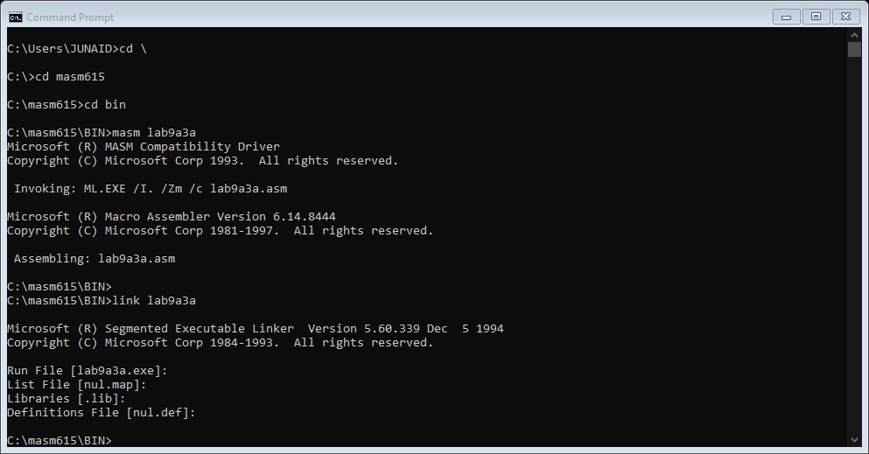

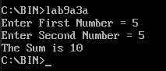

(b) Subtraction:-

Coding:-

Title LAB 9 Activity 3b

.Model Small

.Stack 100H

.Data

Msg DB 'Enter First Number = $'

Msg1 DB 0ah,0dh,'Enter Second Number = $'

Msg2 DB 0ah,0dh,'The Difference Of Two Numbers is = $'

.Code

MAIN PROC

Mov AX,@Data

Mov DS,AX

LEA DX,Msg

Mov AH,9

Int 21h

Mov AH,1

Int 21h

Mov BL,AL

LEA DX,Msg1

Mov AH,9

Int 21h

Mov AH,1

Int 21h

Mov AH,00H

Sub BL,AL

AAS

OR BX,3030H

Mov CX,BX

LEA DX,Msg2

Mov AH,9

Int 21h

Mov DL,CH

Mov AH,2

Int 21h

Mov DL,CL

Mov AH,2

Mov AH,4CH

Int 21h

Main ENDP

END MAIN

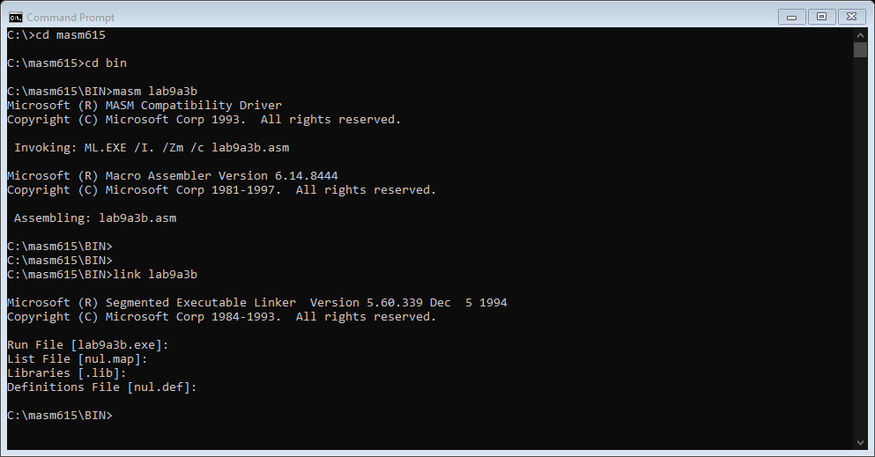

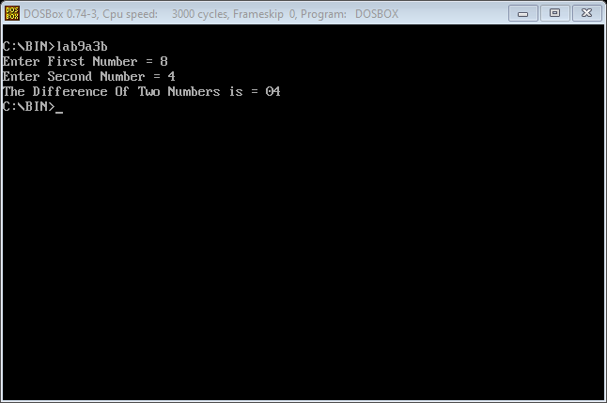

(c) Multiplication:-

Coding:-

Title LAB 9 Activity 3c

.Model Small

.Stack 100H

.Data

Msg DB 'Enter First Number = $'

Msg1 DB 0ah,0dh,'Enter Second Number = $'

Msg2 DB 0ah,0dh,'The Product of Two Numbers = $'

.Code

MAIN PROC

Mov AX,@Data

Mov DS,AX

LEA DX,Msg

Mov AH,9

Int 21h

Mov AH,1

Int 21h

AND AL,0FH

Mov BL,AL

LEA DX,Msg1

Mov AH,9

Int 21h

Mov AH,1

Int 21h

Mov AH,00H

AND AL,0FH

Mul BL

AAM

OR AX,3030H

Mov CX,AX

LEA DX,Msg2

Mov AH,9

Int 21h

Mov DL,CH

Mov AH,2

Int 21h

Mov DL,CL

Mov AH,2

Int 21h

Mov AH,4CH

Int 21h

Main ENDP

END MAIN

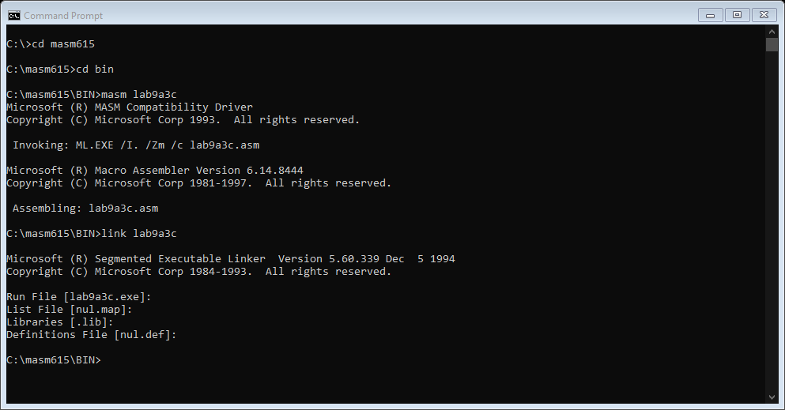

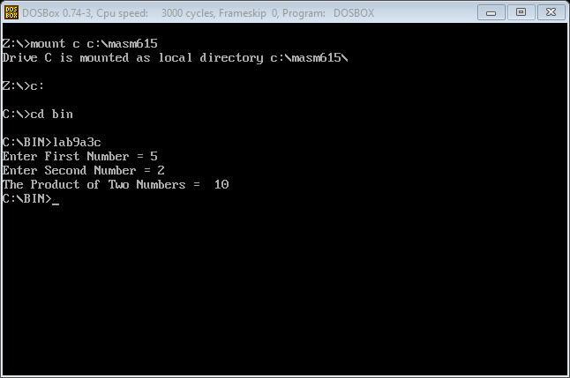

(d) Division:-

Coding:-

Title LAB 9 Activity 3d

.Model Small

.Stack 100H

.Data

Msg DB 'Enter First Number = $'

Msg1 DB 0ah,0dh,'Enter Second Number = $'

Msg2 db 0ah,0dh,'Remainder is = $'

Msg3 db 0ah,0dh,'Quotient is = $'

.Code

MAIN PROC

Mov AX,@Data

Mov DS,AX

LEA DX,Msg

Mov AH,9

Int 21h

Mov AH,1

Int 21h

AND AL,0FH

Mov BL,AL

LEA DX,Msg1

Mov AH,9

Int 21h

Mov AH,1

Int 21h

Mov AH,00H

AND AL,0FH

XCHG AL,BL

AAD

DIV BL

OR AX,3030H

Mov CX,AX

LEA DX,Msg2

Mov AH,9

Int 21h

Mov DL,CH

Mov AH,2

Int 21h

LEA DX,Msg3

Mov AH,9

Int 21h

Mov DL,CL

Mov AH,2

Int 21h

Mov AH,4CH

Int 21h

Main ENDP

END MAIN

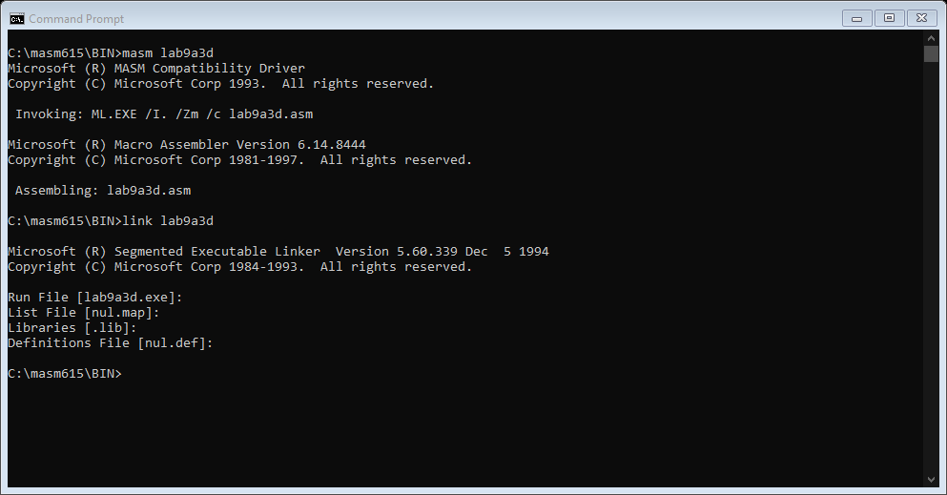

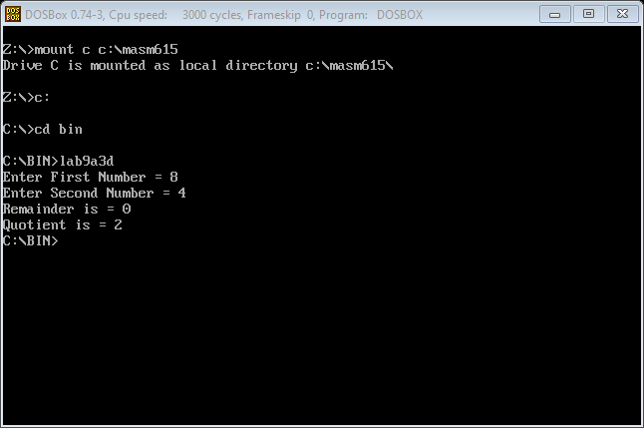

Lab # 10

Activity 1:-

Write and run an Assembly language procedure to display “Computer Science” ten times on computer screen and call it in the main program.

Coding:-

TITLE LAB10ACT1

.MODEL SMALL

.STACK 100H

.DATA

MSG DB 0AH,0DH,'Computer Science $'

.CODE

MAIN PROC

MOV AX,@DATA

MOV DS,AX

MOV CX,10

AGAIN:

CALL PROCEDURE

DEC CX

JNZ AGAIN

MOV AH,4CH

INT 21H

MAIN ENDP

PROCEDURE PROC

MOV DX,OFFSET MSG ;LEA DX,MSG

MOV AH, 9

INT 21H

RET

PROCEDURE ENDP

END MAIN

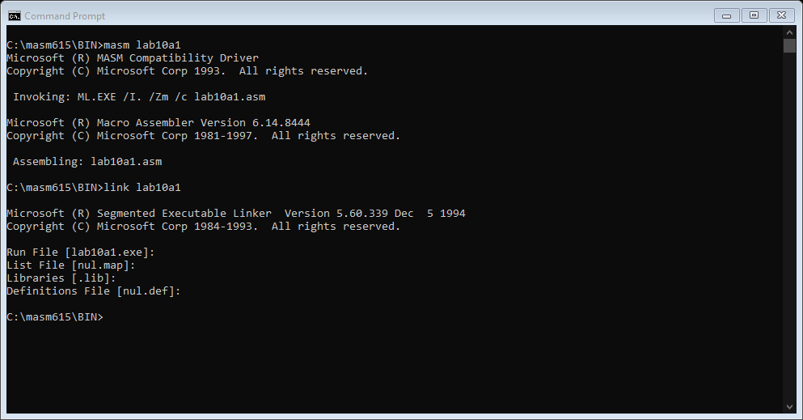

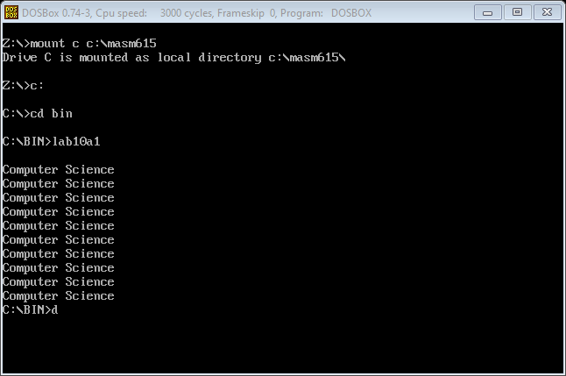

Activity 2:-

Write and run an Assembly language procedure to clear the screen and set the cursor at desired location on the screen and display the table of any number from 2 to 10 and call it in a main program.

Coding:-

TITLE LAB10A2

.MODEL SMALL

.STACK 100H

.DATA

.CODE

MAIN PROC

CALL PROCEDURE

MOV AX,0

MOV BX,0

MOV CX,0

MOV DX,0

MOV CX,10

MOV AL,3

MOV DH,1

AGAIN:

MOV AH,2

MOV DL,20H

INT 21H

MOV AL,3

MUL DH

AAM

ADD AX,3030H

MOV BX,AX

MOV AH,2

MOV DL,BH

INT 21H

MOV AH,2

MOV DL,BL

INT 21H

INC DH

LOOP AGAIN

MOV AH,4CH

INT 21H

MAIN ENDP

PROCEDURE PROC

MOV AH,6

MOV AL,0

MOV CX,0

MOV DX,184FH

MOV BH,7

INT 10H

MOV AH,2

MOV BH,0

MOV DX,0C19H

INT 10H

RET

PROCEDURE ENDP

END MAIN

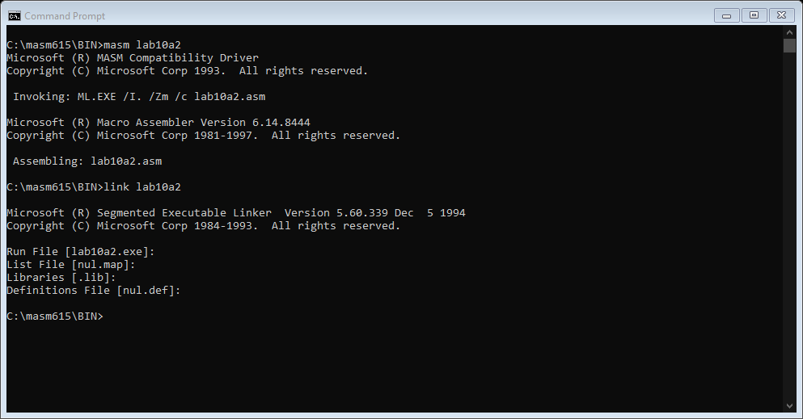

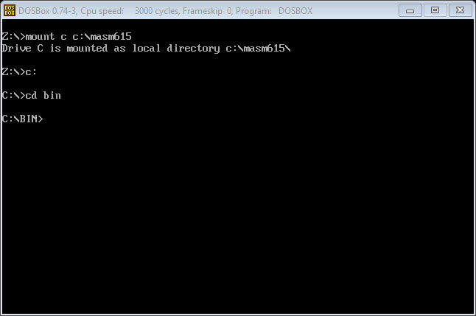

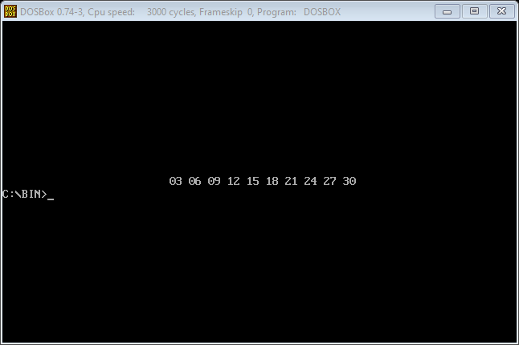

Lab # 11

Activity 1:-

Write and run an assembly language program to generate the Fibonacci series from 0 up to 233.Use buffered input to take starting number from the user(between 0 to 20).

Coding:-

TITLE LAB 11 ACTIVITY 1

.MODEL SMALL

.STACK 100H

.DATA

array db 13 dup (?)

.CODE

MAIN PROC

MOV AX,@DATA

MOV DS,AX

mov cx,13

mov SI,offset array

mov [SI],00h

mov [SI+1],01h

again:

mov al,[SI]

mov bl,[SI+1]

add al,bl

mov [SI+2],al

inc SI

loop again

MOV AH,4CH

INT 21H

MAIN ENDP

END MAIN

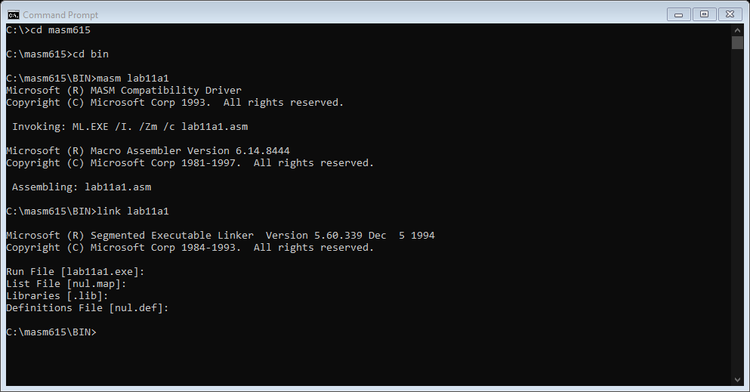

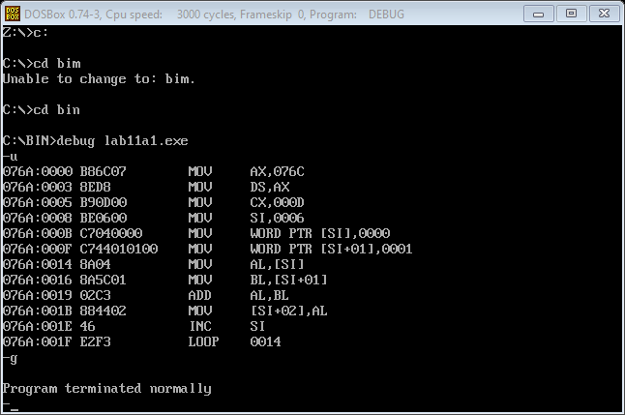

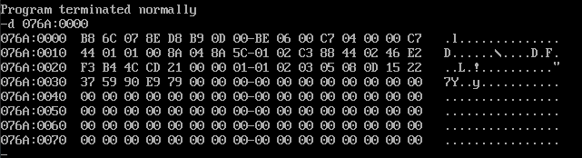

Activity 2:-

Write and run an Assembly language program to generate a factorial of a single digit number given by the user.

Coding:-

TITLE LAB 11 ACTIVITY 2

.MODEL SMALL

.STACK 100H

.DATA

MSG DB 'ENETR A DIGIT TO PRINT THE FACTORIALS = $'

.CODE

MAIN PROC

MOV AX,@DATA

MOV DS,AX

MOV AH,9

LEA DX,MSG

INT 21H

MOV AH,1

INT 21H

SUB AL,30H

MOV CL,AL

SUB CL,1

MOV BL,AL

SUB BL,1

AGAIN:

MUL BL

SUB BL,1

LOOP AGAIN

MOV AH,4CH

INT 21H

MAIN ENDP

END MAIN

